# Docker Assignment-1

# Install Docker and Pull Ubuntu container

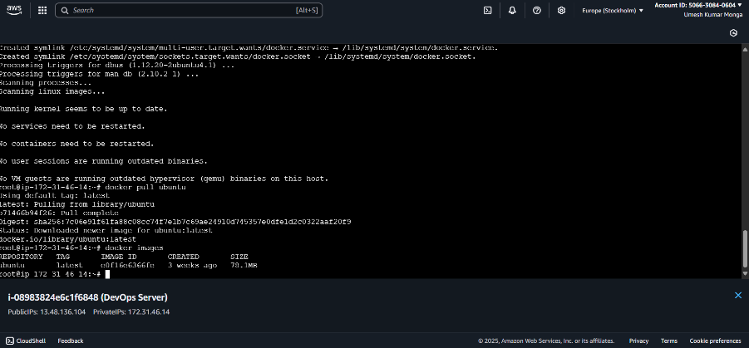

# Run this container and map port 80 on the local

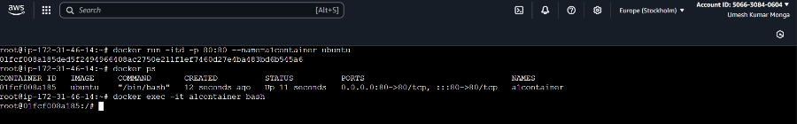

# Install Apache2 on this container

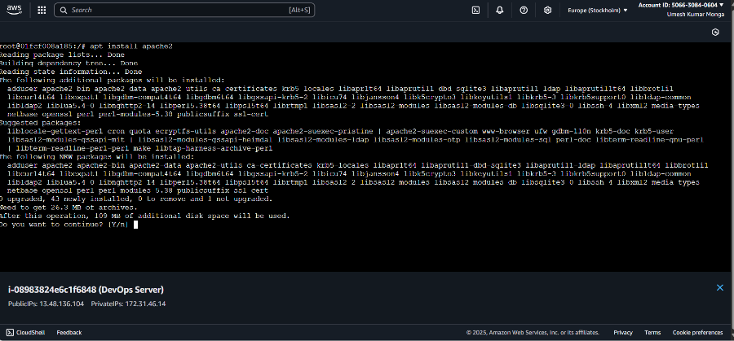

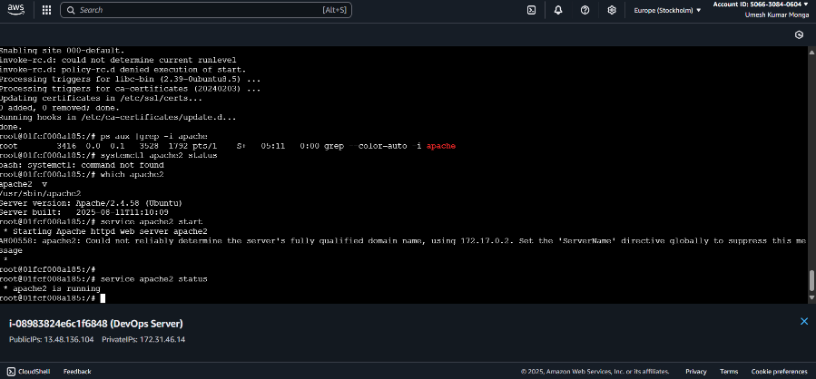

# Check if you are able to access the Apache page on your browser

